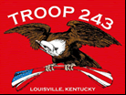
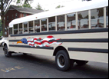
TROOP 243
February 1st, 2016
Boy Scouts of America
Chartered by St. John Paul II Catholic Church

3044 Hikes Lane Louisville, Ky 40220
3521 Goldsmith Lane http://www.troop243.com

Troop 243 Outings & Activities – Troop 243 starts off with troop leadership elections. A new Senior Patrol Leader and Patrol Leaders will all be elected and the new SPL will appoint his 2 ASPLs. A First Aid Merit Badge class follows closely after that with the Troop 243 high adventure fundraising pancake breakfast on February 7th. The most popular camp out we do on a weekend, the Winter Freeze is a February tradition and will be held the weekend of Saturday February 13th. A Personal Fitness Merit Badge class will be held on February 21st with the kickoff to this year’s flower sale following on the next Wednesday. We wrap up the month with a crossover ceremony for our newest scouts from St. Gabriel and the normal scout and adult leadership meetings.

Troop and Patrol Meetings on Wednesdays - All are welcome. Scouts in Field/Class A uniforms are expected for all troop meetings while class B uniforms are ok for patrol meetings. Except where noted, all meetings are held at St. Barnabas. SERVICE PATROLS should arrive 15 minutes early to set up for the meeting.

February 3rd, 7:00 PM – Troop Meeting @ Engineering and troop leadership elections – The service patrol is Combat Spartans
February 10th, 7:00 PM – Patrol Meetings – There is no patrol meeting due to Ash Wednesday
February 17th 7:00 PM – Troop Meeting @ Chemistry – The service patrol is Danger.
February 24th, 7:00 PM – Troop Court of Honor, The service patrol is Nuclear Squirrels
AED/First Aid Merit Badge Class – February 6th, we will host a First Aid/AED merit badge class from 9:00AM to 5:00PM. We are inviting adults who have not had CPR and scouts who do not have the First Aid Merit badge. We have to have a solid count on the participants. To that end, please reply to Bruce Bohn at scoutsecretary@bellsouth.net so I can get a count. RSVPS must be received no later than February 3rd. Notice that this is an all day class so be sure to bring a lunch, drink and any other snack type thing you may need to get you through the day. Do not count on there being a fridge in which to keep your lunch.
Scout Leadership Elections – The first Week of February, we will have our troop leadership elections. Senior Patrol Leader candidates will speak to the troop about why they will be the best choice and the troop will choose the new leader. That leader will then choose 2 assistants with whom he will work during his tenure. Lastly, the New Patrol Leaders will be elected. All new leaders will be installed at the February Court of Honor on February 24th.
High Adventure Pancake Breakfast Fund Raiser – Put on your calendar the Troop 243 High Adventure Pancake Breakfast to be held 9-1 on Sunday February 7th. This annual breakfast is now intended to help fund High Adventure trips so they might be more affordable for individual scouts.
Troop Leadership Meetings – Troop Leadership Meetings will be held on at the end of the month as usual. The PLC meets on Sunday, February 28th while the adults will meet from 7-9 Monday February 29th.
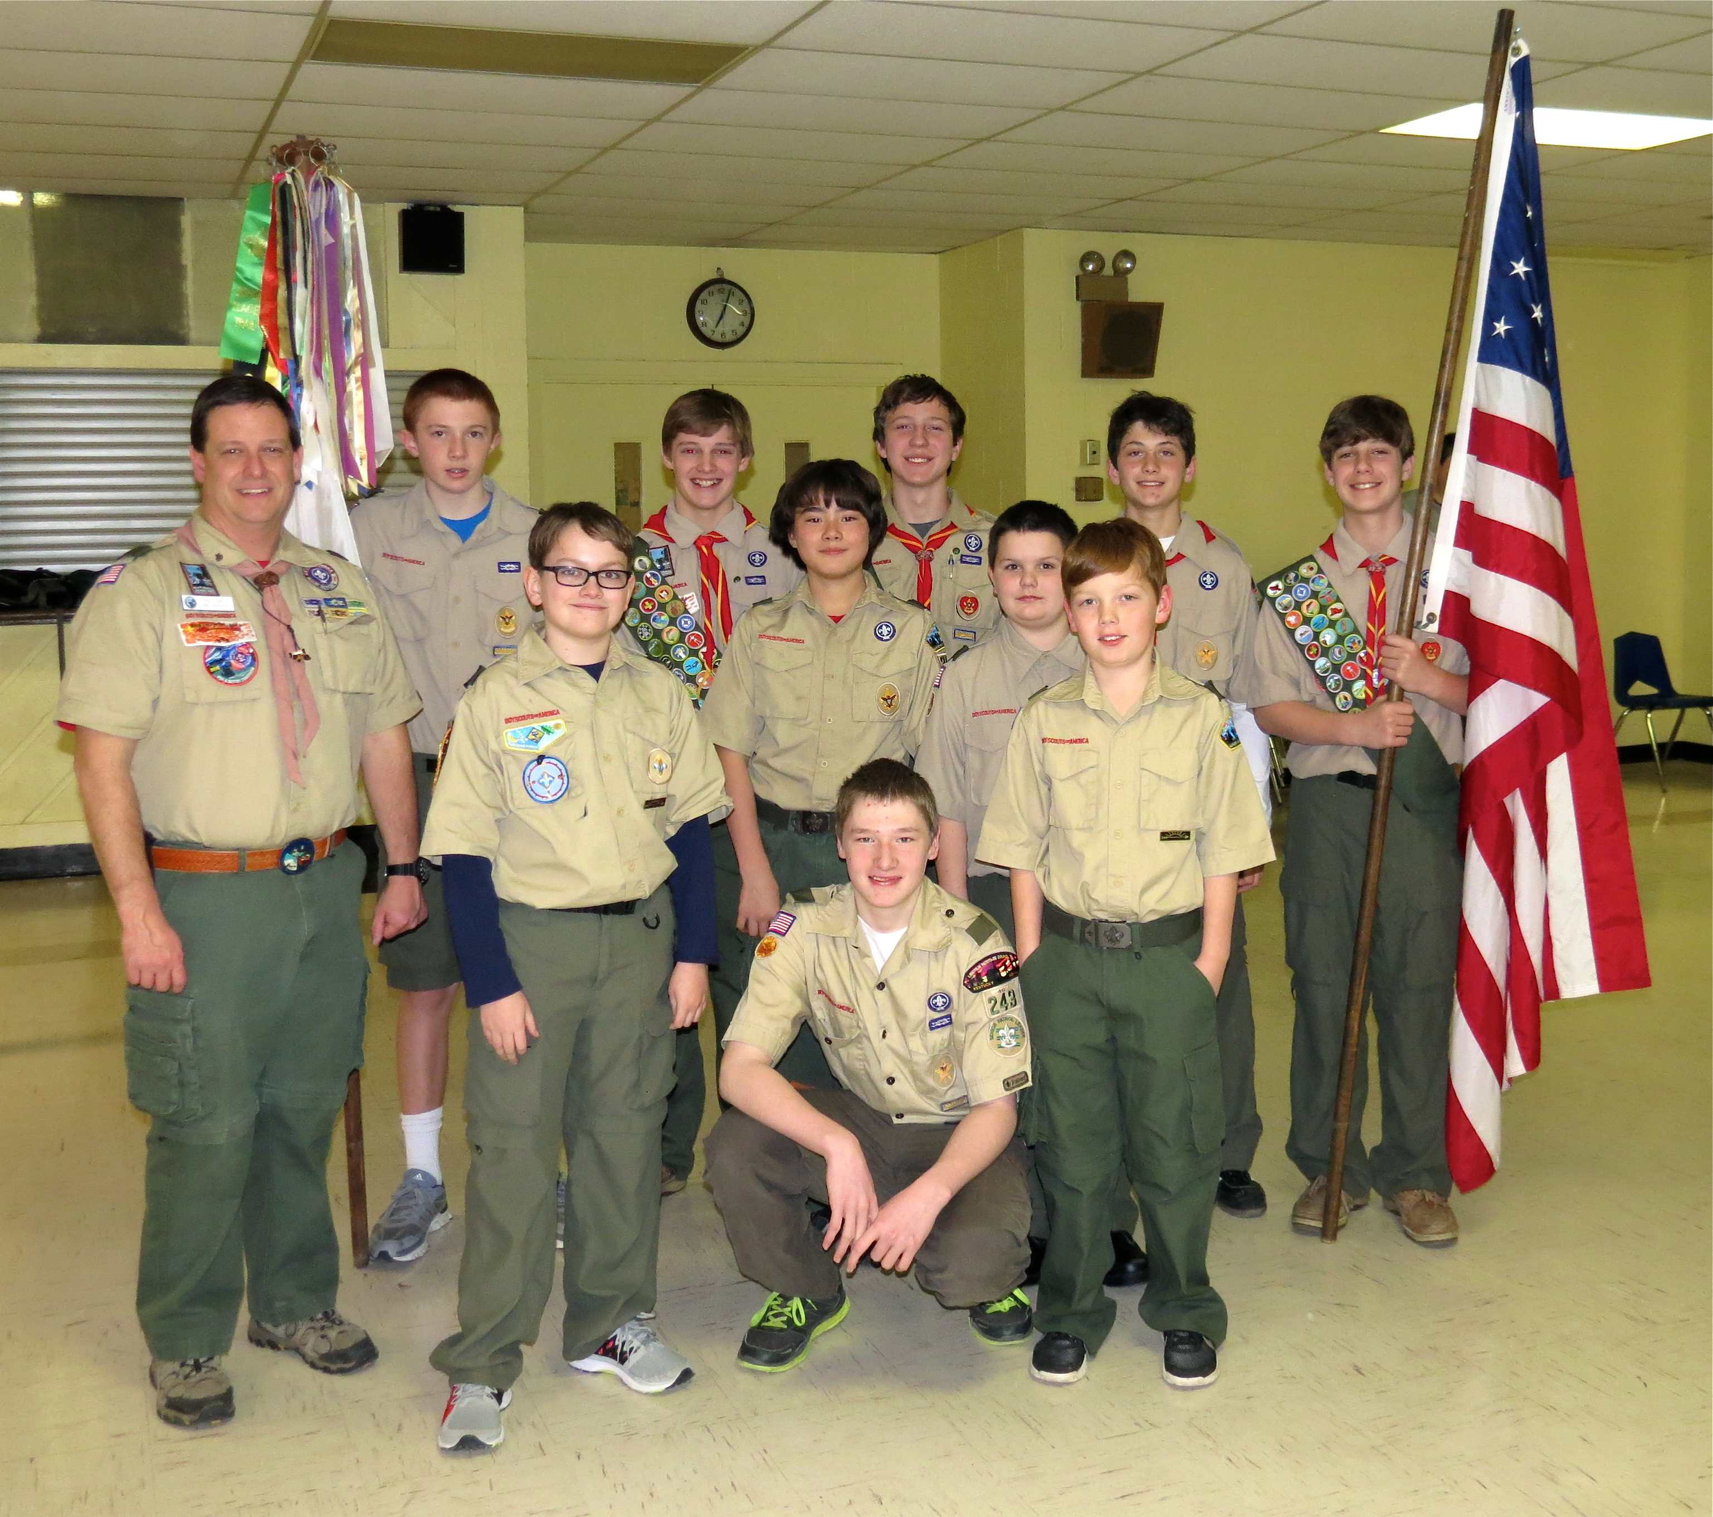
To the right is the group of scouts who were on hand to welcome Chase Miller and Nathan King, from Pack 756, to Troop 243. The Crossover included a color guard of which we were very proud, a ceremony stressing the values of the Eagle trail and a hardy welcome for our new Boy Scouts. They will join the soon to crossover scouts from St. Gabriel and form a new patrol that will focus on the progress of these new scouts.

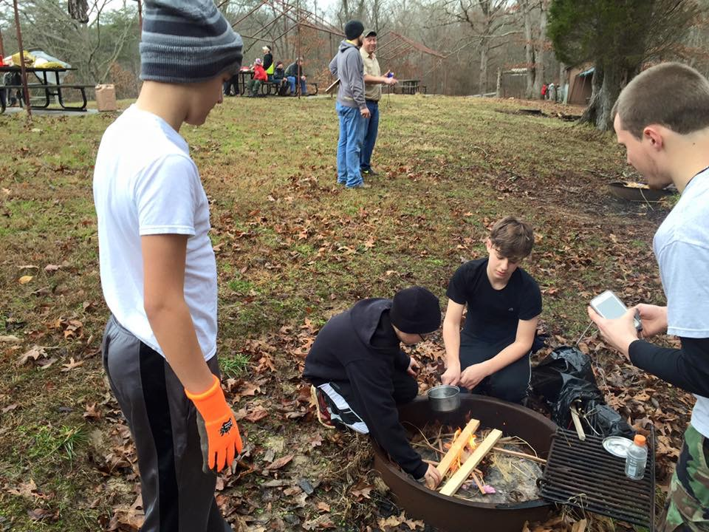
Klondike Derby – As usual Troop 243 was represented well at the Klondike Derby this year. The Combat Spartans won the overall orienteering and camp confusion part of the competition. Congrats to the Combat Spartans! Below are some pictures.

To the left, scouts test their fire building ability in a timed activity. While matches are allowed, there are time penalties if you use them. Below, it appears to be break time.

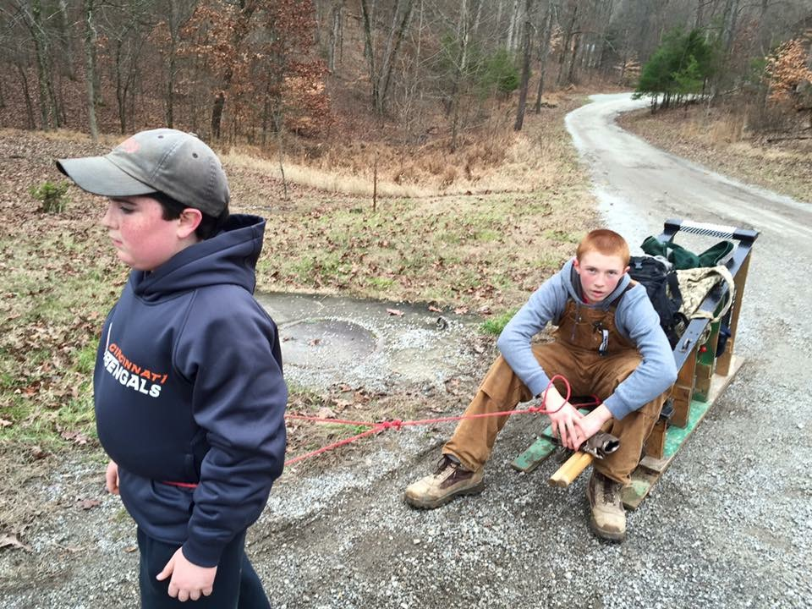

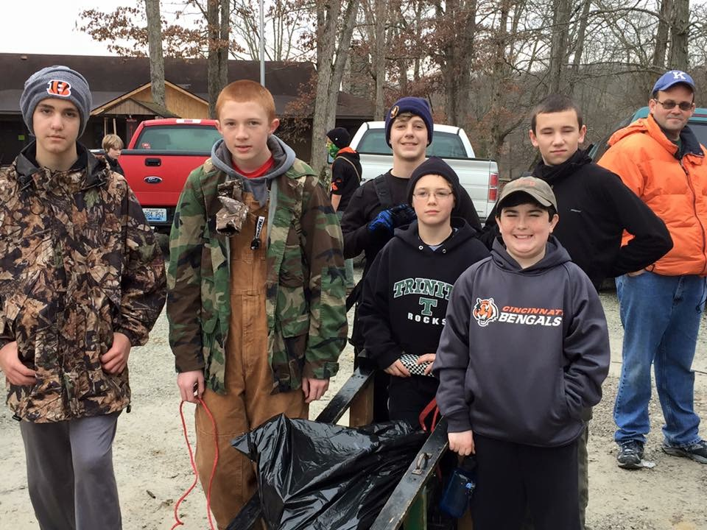

To the left, this patrol is ready to begin the competition. Below, this same patrol is receiving instructions at one of the competition stops.



